EAP Working Group

22|02|2022

Executive summary of Session 2 of the Regulatory/HTA/Payer EAP

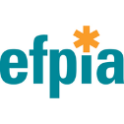
This project has received funding from the Innovative Medicines Initiative 2 Joint Undertaking under grant agreement No 820755. This Joint Undertaking receives support from the European Union’s Horizon 2020 research and innovation programme and EFPIA and bioMérieux SA, Janssen Pharmaceutica NV, Accelerate Diagnostics S.L., Abbott, Bio-Rad Laboratories, BD Switzerland Sàrl, and The Wellcome Trust Limited.
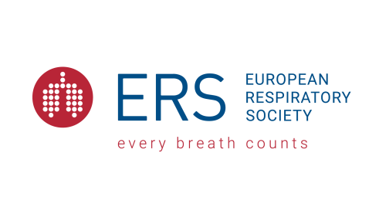
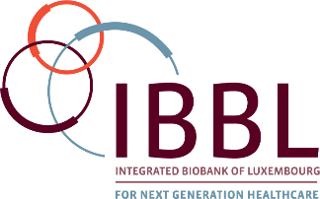
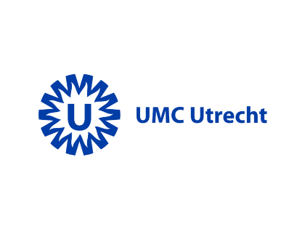

Second EAP session

Meeting overview
The second session of the VALUE-Dx Expert Advisory Panel (EAP) was held virtually on 11 March 2021. There were six members of the EAP present.

Topics and themes discussed
1. Value-Dx progress update
Progress during the last 6 months since the first EAP session including the point prevalence audit surveys, their extension due to COVID-19 and plans for the clinical trials which will be conducted within VALUE-Dx.
2. Cost-effectiveness evidence required in different jurisdictions to make funding decisions and key sources of unit costs, particularly tests.
3. The lifetime economic model to assess the cost-effectiveness of rapid diagnostics:
- The demographic model
- The consultation model
- The AMR forecasting model
- Assumptions
- Relevance of certain outcomes
4. How the pandemic has changed the importance of diagnostics

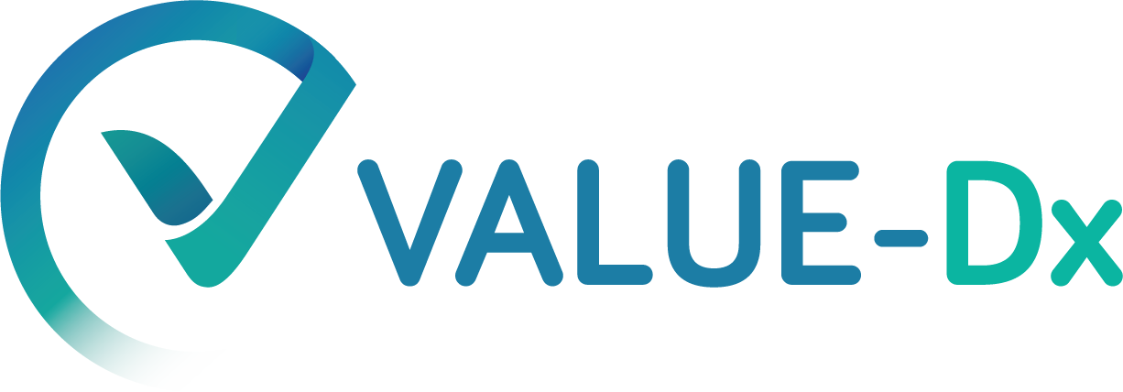
Copyright 2019 VALUE-Dx
www.value-dx.eu

www.value-dx.eu

www.value-dx.eu

www.value-dx.eu

www.value-dx.eu

www.value-dx.eu

www.value-dx.eu

www.value-dx.eu

www.value-dx.eu

www.value-dx.eu

www.value-dx.eu

www.value-dx.eu

www.value-dx.eu

www.value-dx.eu

www.value-dx.eu

www.value-dx.eu
www.imi.europa.eu

www.imi.europa.eu

www.imi.europa.eu

www.imi.europa.eu

www.imi.europa.eu

www.imi.europa.eu

www.imi.europa.eu

www.imi.europa.eu

www.imi.europa.eu

www.imi.europa.eu

www.imi.europa.eu

www.imi.europa.eu

www.imi.europa.eu

www.imi.europa.eu

www.imi.europa.eu

www.imi.europa.eu

