y
EAP Working Group
22|02|2022

Executive summary of Session 1 of the VALUE-Dx Regulatory/HTA/Payer EAP

This project has received funding from the Innovative Medicines Initiative 2 Joint Undertaking under grant agreement No 820755. This Joint Undertaking receives support from the European Union’s Horizon 2020 research and innovation programme and EFPIA and bioMérieux SA, Janssen Pharmaceutica NV, Accelerate Diagnostics S.L., Abbott, Bio-Rad Laboratories, BD Switzerland Sàrl, and The Wellcome Trust Limited.
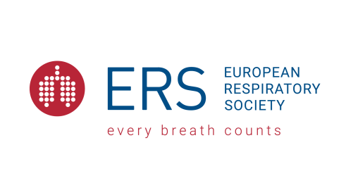
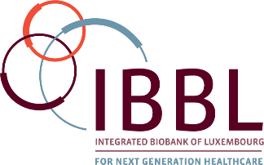
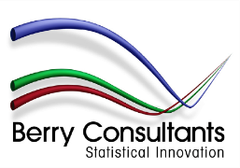
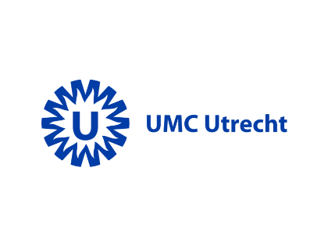

First EAP session

Meeting overview
The first session of the VALUE-Dx health technology assessment (HTA) and payer Expert Advisory Panel (EAP) was held virtually on 30th September 2020.
There were 11 members of the EAP Present.

Topics and themes discussed
1. Overview of Value-Dx project
An overview including the vision, objectives, governance, work package (WP) structures and project timelines, and an update on the point prevalence audit surveys and their extension due to the COVID-19 pandemic/links to the RECOVERY trial. The overview included a brief description of the design of the planned Value-Dx clinical trials.
2. Objectives for Work Package 5 including clinical and economic value frameworks and health economics and assessment policy.
3. Impact of the COVID-19 pandemic on:
- the interest in value-based healthcare and acceleration of its implementation
- lessons learned from successes & failures in implementation of diagnostics and application to market entry of in-vitro diagnostics (IVDs) in the non-COVID-19 context (AMR)
4. Holistic value assessment for diagnostics that goes beyond “mere patient outcomes” and the potential for transparent dialogue with manufacturers, academics, regulators, HTA bodies, funders, & the health system from early in product development.
5. Conducting research on experiences of introducing new diagnostic tests in European community care to manage respiratory tract infections, particularly in response to the ongoing COVID pandemic including recruitment of stakeholders, which countries and organisations.
6. Items relevant to the medium to long term for development and implementation of diagnostics including:
- Future drivers, trends and needs
- Research and development
- Enablers, capabilities and resources

Copyright 2019 VALUE-Dx
www.value-dx.eu

www.value-dx.eu

www.value-dx.eu

www.value-dx.eu

www.value-dx.eu

www.value-dx.eu

www.value-dx.eu

www.value-dx.eu

www.value-dx.eu

www.value-dx.eu

www.value-dx.eu

www.value-dx.eu

www.value-dx.eu

www.value-dx.eu

www.value-dx.eu

www.value-dx.eu
www.imi.europa.eu

www.imi.europa.eu

www.imi.europa.eu

www.imi.europa.eu

www.imi.europa.eu

www.imi.europa.eu

www.imi.europa.eu

www.imi.europa.eu

www.imi.europa.eu

www.imi.europa.eu

www.imi.europa.eu

www.imi.europa.eu

www.imi.europa.eu

www.imi.europa.eu

www.imi.europa.eu

www.imi.europa.eu

